CSC 134 Spring 2019
Assignment 4
Total: 100 points

This homework allows students to practice the development of a database using MySQL.

Section 1
Using SQL, create tables according to the given schema shown in Figure 1. The ER diagram is shown in Figure 3. You must create your database using exactly the same names for tables and attributes, using the given type. The type of each attribute is defined in Figure 2. Note that it is case-sensitive.

Branch (name, address)
Customer (ssn, fname, lname, phone, address, fv_branch) foreign key (fv_branch) references Branch (name)
Account (acc_no, balance, open_date, atype)
Owns( ssn, acc_no, own_date) foreign key (ssn) references Customer(ssn), foreign key (acc_no) references Account (acc_no)
Loan( loan_no, amount, ltype)
Payment ( loan_no, payment_no, amount, method, status, due_date) foreign key(loan_no) references Loan(loan_no)
Borrows(ssn, loan_no) foreign key (ssn) references Customer(ssn), foreign key (loan_no) references Loan (loan_no)
Figure 1 Schema

Branch (name: VARCHAR(25), address: VARCHAR(50))
Customer (ssn: CHAR(9), fname: VARCHAR(25), lname: VARCHAR (25) , phone CHAR(10), address: VARCHAR (50), fv_branch: VARCHAR(25) )
Account (acc_no: CHAR(9), balance: DECIMAL (15,2), open_date: DATE, atype: VARCHAR(10))
Owns( ssn: CHAR(9), acc_no: CHAR(9), own_date: DATE) foreign key (ssn) references customer(ssn), foreign key (acc_no) references account (acc_no)
Note: DATE is in the format of ‘yyyy-mm-dd’.
Loan( loan_no: CHAR(9), amount: DECIMAL(15,2), ltype: VARCHAR(10))
Payment ( loan_no: CHAR(9), payment_no: CHAR(4), amount: DECIMAL(15,2), method: VARCHAR(10), status: VARCHAR(10), due_date: DATE) foreign key(loan_no) references loan(loan_no)
Borrows(ssn: CHAR(9), loan_no: CHAR(9)) foreign key (ssn) references customer(ssn), foreign key (loan_no) references loan (loan_no)
Figure 2 Schema with type

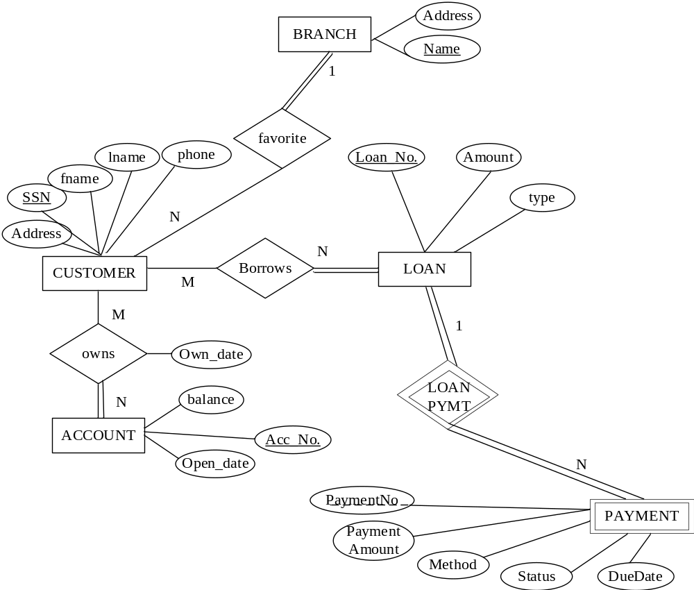
Figure 3 ER Diagram

Section 2
- Populate the database. Insert at least two tuples to the “Payment” table. For each of the other tables, insert at least one tuple. For the payment table, you can populate some payments with the following information: method= ‘not know’, status= ‘not paid’, to simulate the situation that some payments have not been paid yet. You can also populate some paid payments, such as: method = ‘Check’, status = ‘Paid’.
(2) Execute one delete statement to the “Payment” table.
(3) Execute one update statement to the “Account” table to change the value of “balance”.

Section 3
Specify the statements to drop all the tables. Pay attention to the order of the drop statements in order to drop everything successfully.

Submission

Submit the following files to Canvas. Note: Submit through any other ways, such as email attachment, will not be graded. Do not zip them.
- Create table statements (file name must be: 1_create_table.txt)
- Insert statements to populate database, also include one update statement and one delete statement as required by Section 2 (file name must be : 2_populate_db.txt)
- Drop tables statements (file name must be: 3_drop.txt)

